* Startproject
* Start app blog
* Startapp portfolio
* Build a Project model in portfolio app
* Pip install pillow (images dependency)
* Migrate (all originally installed app
* Makemigration (tro the new model)
* Migrate again.
* Python manage.py createsuperuser
* See admin page
* Add admin.py
* Add a Projec in admin page
* Add MEDIA_ROOT in settings
* Add static to the main url + MEDIA_URL in settings
* Add a home page (insdie portfolio app), just a big hello header
* Send the Project to the home template and show how to browse projects.
* FW url to apps. blog
* (create blog model – maybe self practice)
* Admin, html…
* Show dates with default
* Order_by
* Load a static image.
* Static a tag (download something)
* Deatil view. Func
* Show blogs.count in the blog page
* Plurlize
* Date format
* Short preview of description
* Escape in description (or |striptags to ignore html tags
* Take a full html from bootstrap
* Base template (TEMPLATE_DIR in settings)
* Bootstrap
  + Title
  + Logo
  + Menue links
* Serve the project and pythonanywhere
  + Pull from git
  + Mkvirtualenv python=/usr/bin/python3.8 name
  + Deactivate
  + Workon name
  + Cd .virtualenvs to see all envs
  + Pip install Django pillow
  + Pwd of the project
  + Name of the project
  + Web add a new web app
    - Manual configuration
    - Name of virtual env
    - Full path home/…
    - [*]
    - Debug off
    - Add STATIC_ROOT
    - Python manage.py collectstatic
    - Set static pointer on the web
    - Set media pointer as well
    - 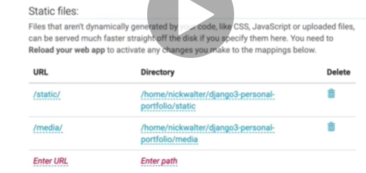
    - https out of the box. Force it
    - gitignore.io
    - edit a .gitignire file on the server add /static/
    - clean server repository, push to giyhub and pull to local.
    - Add local_setting.py and add to the settings
    - Flow of deploy update now:
      * Check pip freeze > requierments.txt
      * Push
      * Pull
      * Requerements
      * Migrate
      * Coolect static